TRAINING OUTLINE

 |  | 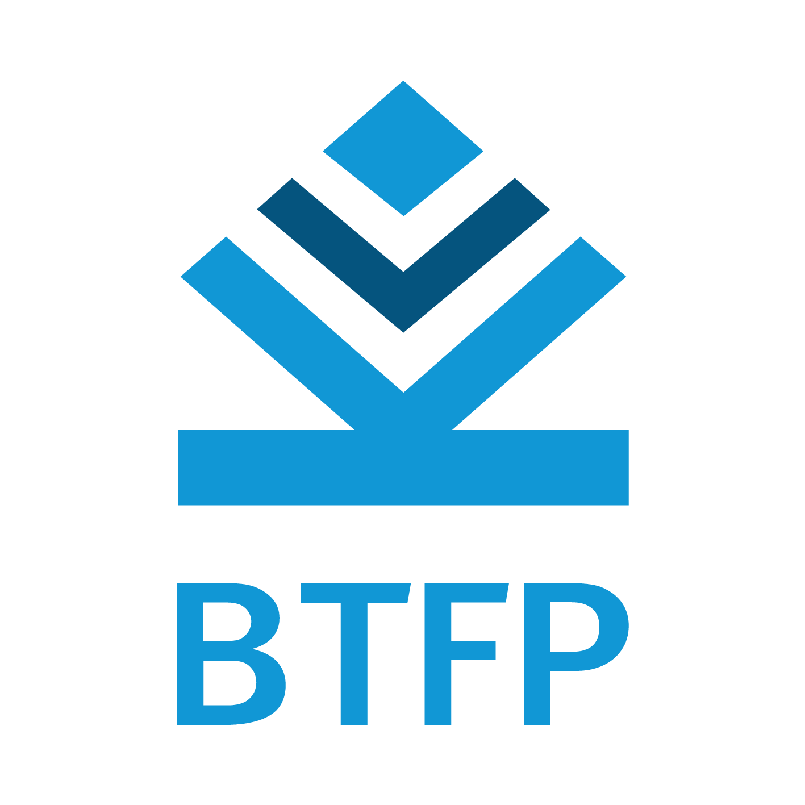

NBTC-ITU Training
on
Building Distributed Ledger Technologies (Blockchain) Projects
(Train the Trainer Course)
5-8 November 2019, Hotel Lancaster, Bangkok, Thailand

COURSE DESCRIPTION

Title | Building Distributed Ledger Technologies (Blockchain) Projects
Method of delivery | Face-to-face
Objectives | The training will provide an overview of Distributed Ledger Technologies (DLTs) technologies, trends and assessment techniques. It will also provide intermediate-to-advanced skills for developing DLT based projects.
Dates | 5-8 November 2019
Duration | 4 days
Prerequisites | Participants should have basic computer programming skill in these languages: C, C++, Javascript,  Participants must bring their own laptop computers.
Registration deadline | 16 October 2019

LEARNING OUTCOMES

Upon completion of this training, participants will be able to
- Understand various DLTs and application trends
- Distinguish between various DLTs choices based on an assessment framework
- Gain hands-on exercise on how to develop DLT based application.
- Acquire perspective of what is required for developing DLT products.

TARGET POPULATION
Technological/Academic Staff from policy makers, regulators, telecom operators, researchers and academia responsible for or interested in teaching and developing DLT in Thailand.

FACILITATOR/EXPERTS
The training will be conducted by experts from ITU.

DRAFT TRAINING SCHEDULE AND CONTENTS / AGENDA
(Updated information will be available at http://www.itu.int/itu-d/asp)

DRAFT AGENDA
5 November 2019 (Day-1)
0830-0900 | REGISTRATION
0900-0930 | Opening Session:  Group Photo
0930 – 1045 | Session 1: Global overview of DLT (including Blockchain) Ecosystem and Technologies  Objective: To provide an overview of DLT Ecosystem and technologies.  [Skylar Hurwitz]
1045-1100 | COFEE BREAK
1100-1230 | Session 2: DLT based applications and an assessment framework  Objective: To provide an overview of DLT application and an assessment framework.  [Skylar Hurwitz]
1230-14:00 | LUNCH BREAK
1400-1500 | Session 3: Developing DLT projects  Objective: To understand the framework for developing and managing DLT projects  [Jamie Cerexhe]
1500-1530 | COFEE BREAK
1530-1700 | Session 4: Working group exercise  Objective: tbc  [Jamie Cerexhe]
6 November 2019 (Day-2)
0900-1030 | Session 5: Security Issues in DLTs  Objective: To provide an overview of security issues in DLTs.  [Skylar Hurwitz]
1030-1100 | COFEE BREAK
1100-1230 | Session 6: DLT Programming  Objective:  [Jamie Cerexhe]
1230-1400 | LUNCH BREAK
1400-1500 | Session 7: DLT Programming  Objective:  [Jamie Cerexhe]
1500-1530 | COFEE BREAK
1530-1700 | Session 8: Working Group / Lab Exercise  [Jamie Cerexhe]
7 November 2019 (Day-3)
0900-1030 |  |  |  | Session 9: DLT policy and regulation  Objective: To understand the policy and regulatory issues in DLT  [Ashish Narayan, ITU]
1030-1100 |  |  |  | COFEE BREAK
1100-1230 |  |  |  | Session 10: Working Group / Lab Exercise  Objective:  [Jamie Cerexhe]
1230-1400 |  |  |  | LUNCH BREAK
1400-1530 |  |  |  | Session 11: Working Group / Lab Exercise  Objective:  [Jamie Cerexhe]
1530-1600 |  |  |  | COFEE BREAK
1600-1700 |  |  |  | Session 12: Working Group / Lab Exercise  Objective:  [Jamie Cerexhe]
8 November 2019 (Day-4)
0900-1030 | Session 9: DLT case study  Objective: To showcase a DLT based case study  [Ashish Narayan, ITU]
1030-1100 | COFEE BREAK
1100-1230 | Session 10: Working Group / Lab Exercise  Objective:  [Jamie Cerexhe]
1230-1400 | LUNCH BREAK
1400-1530 | Session 11: Working Group / Lab Exercise  Objective:  [Jamie Cerexhe]
1530-1600 | COFEE BREAK
1600-1700 | Session 12: Working Group / Lab Exercise  Objective:  [Jamie Cerexhe]

 |  | WORKWORKSHOP CLOSING
METHODOLOGY
The face-to-face programs will include
  - Instructor-led presentations,
  - Case studies,
  - Group exercises

TRAINING COORDINATION
ITU coordinator:
Mr. Ashish Narayan,
Program Co-ordinator, ITU Regional Office for Asia & the Pacific, 5th Floor, Thailand Post Training Centre,111Moo3 Chaengwattana Road, Laksi Bangkok 10210,Thailand
Tel: +66 257 500 55, FAX: +66 257 535 07
Email: ashish.narayan@itu.int

NBTC Coordinator:
Mrs. Thanyaporn Chotichanapibal,
Office of NBTC, 6th Floor, I Tower Building,
888 Vibhavadi Rangsit Road , Jatujak, Bangkok 10900, Thailand
Tel: +66 255 481 02, FAX: +66 255 481 00
Email: thanyaporn.choti@gmail.com

